Implementing and Documenting Software Architecture Patterns 487W
By Robert Bennethum

Student Course Registration System

Description
This system is to be able to allow students to view, register, and drop courses in addition to viewing their current schedule.

Pattern Justification
I will use Model View Controller for this problem. This would be because the pattern is good for separating the UI, operations, and schedule data making it so then different parts could be edited individually without effecting the other parts. This makes it ideal because UI changes could happen for ease of use without needing to change the logic.

Architecture Diagram
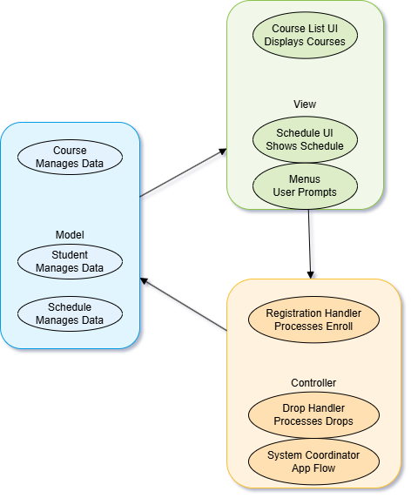

Components
In the model section, there it has the course details, as shown.
In the view section is all about what the user sees, as shown.
In the controller section is all about what the program functionally does, as shown.

Non-Functional
The code can be maintained in each part without affecting each other.
Easy to add new features and views.
Makes clear separation between each.

Invoice Processing System

Description
This program will take in the invoice data, make sure that it is valid, calculate the costs with the taxes, and output a nicely formatted invoice to give to the customer.

Pattern Justification
I will use Layered Architecture for this program because it is good for separating for business use. For example, there are the different layers that will show the user interface, the user interface management and authentication, the business logic, and the system support. This would be good for spreading across teams which can specialize in specific parts of the system.

Architecture Diagram
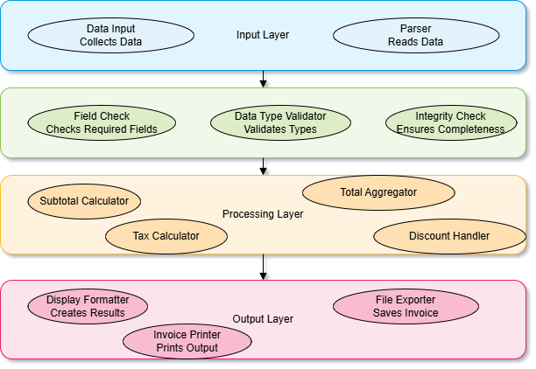

Components
Each layer is shown with a brief description of each part below the name.

Non-Functional
Each layer is by itself meaning that it is easy to add new layers for new major functions. In addition, it is easier to test each layer independently to resolve bugs.

